**R TOOL**

**T.HEMA VARSHITHA**

**192011258**

1. **MEAN,MODE,MEDIAN:**

**FORMULA:**

* Mean=sum of all observations/no of observations
* Median= mid element of the given list or n1 +n2/2.
* Mode=most frequently occurred element in given list.
* Standard deviation=√variance.

**SYNTAX:**

e<-c(8,6,4,12,16,18,20)

**Mean:** mean(e)

**Median:** median(e)

**Mode:** mode(e)

**Standard deviation:** sd(e)

**OUTPUT:**

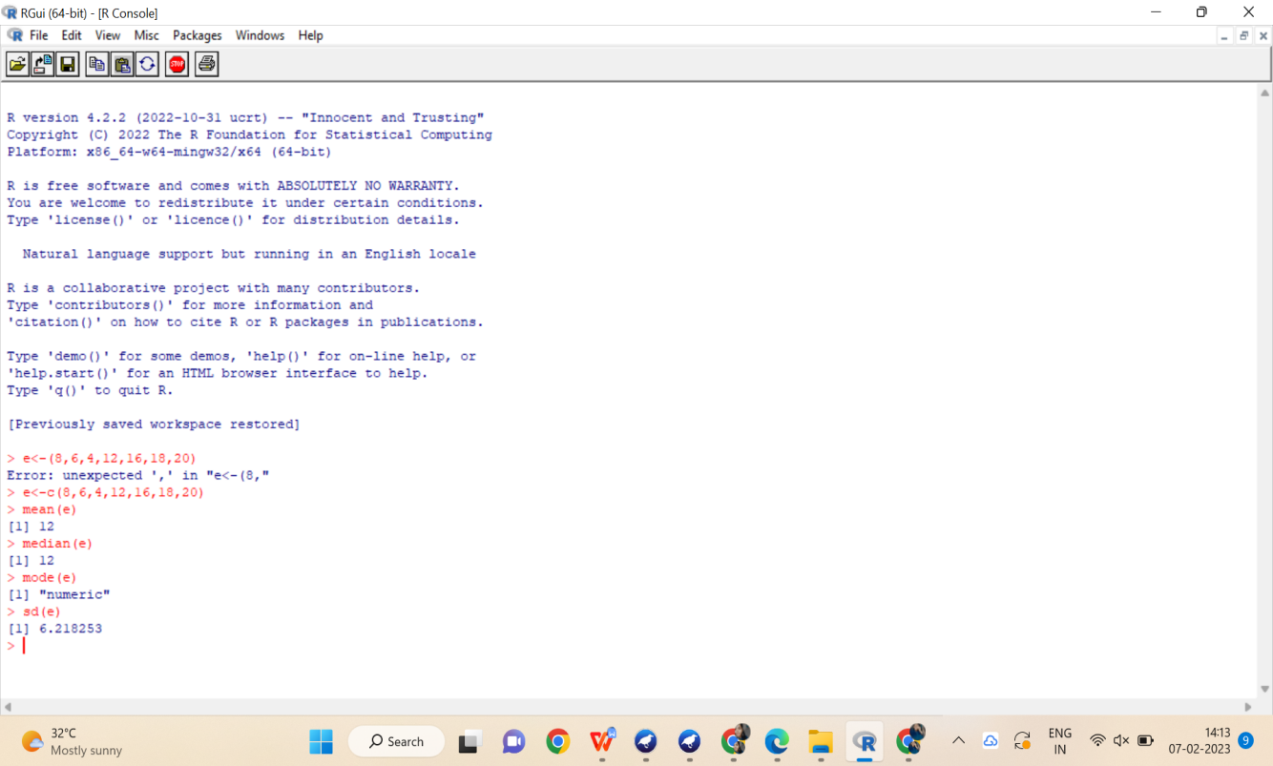

1. **BAR CHART,SCATTER PLOT,BOX PLOT,HISTOGRAM:**

**SYNTAX:**

e<-(10,20,30,40,50,60)

**Bar plot:** barplot(e)

**Box plot:** boxplot(e)

**Histogram:** hist(e)

**Scatterplot:** plot€

**OUTPUT:**

**Bar plot:**

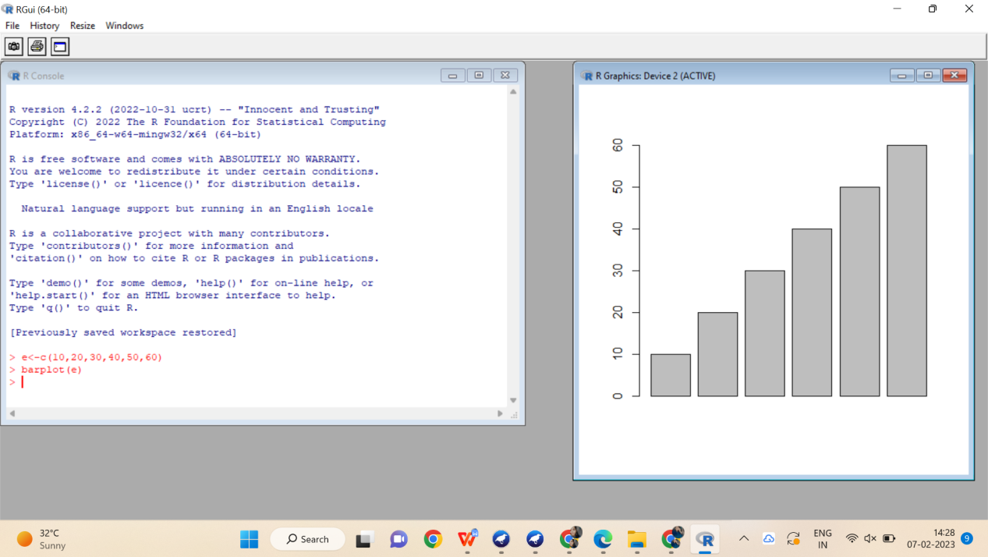

**Box plot:**

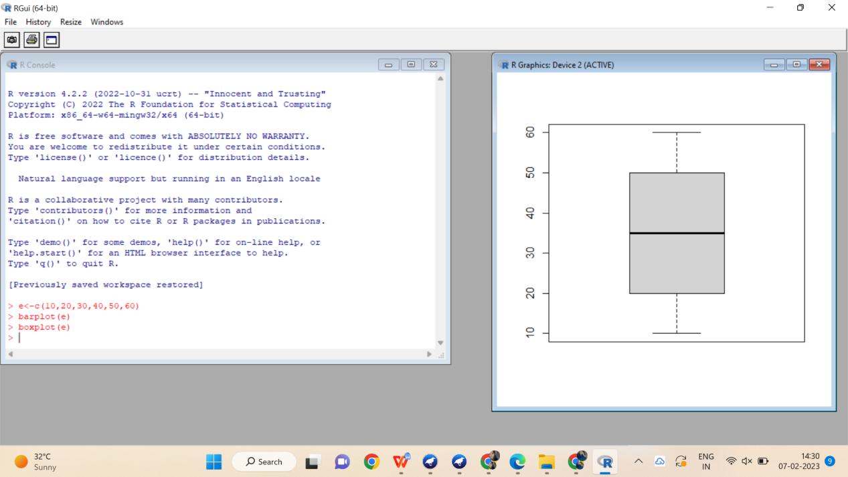

**Histogram:**

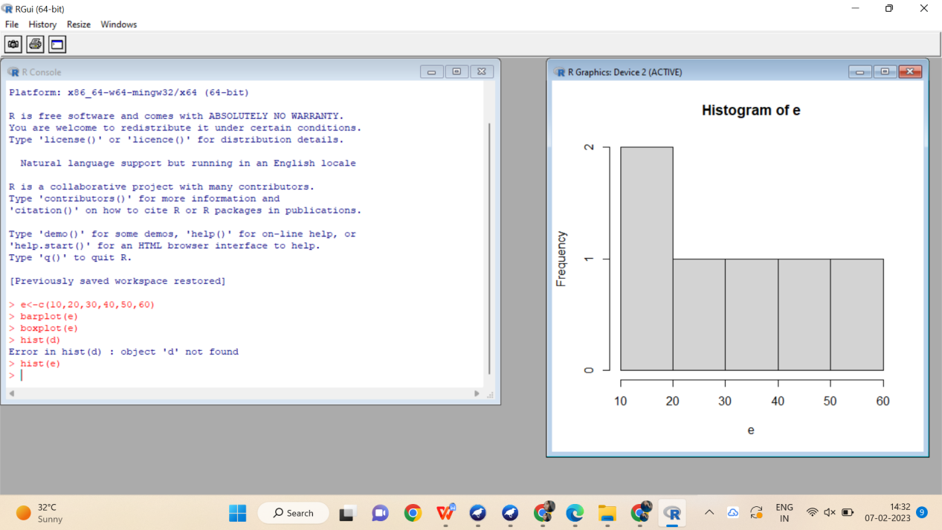

**Scatter plot:**

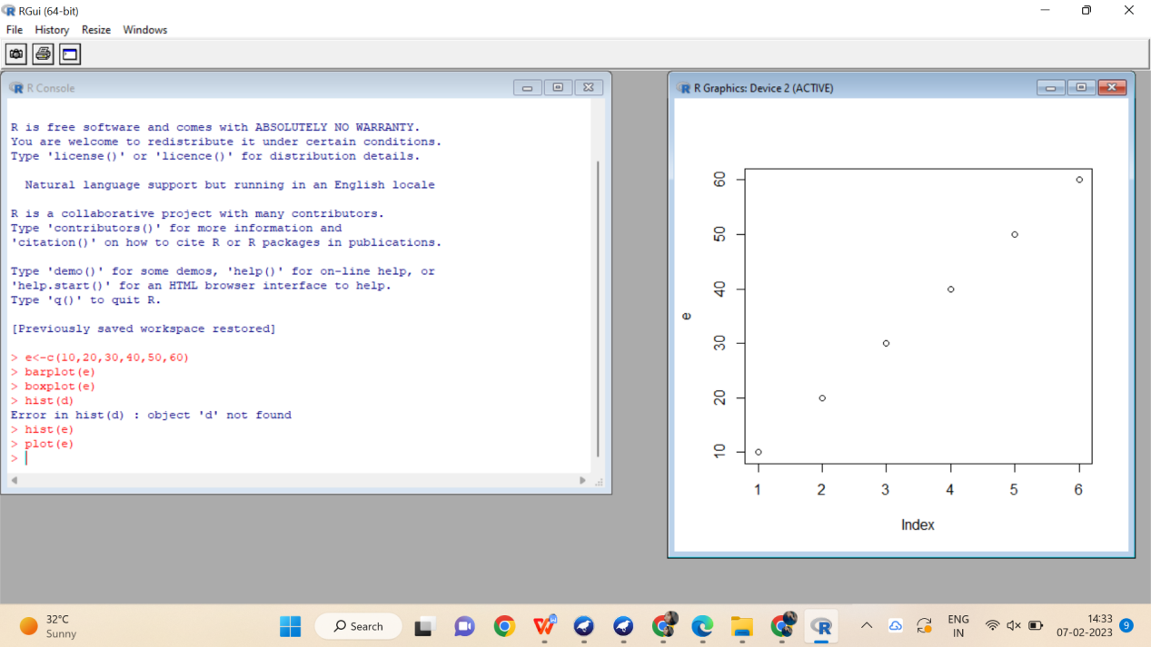

1. **QUANTILE,RANGE,IQR:**

**SYNTAX:**

e<-c(8,6,4,12,16,18,20)

**IQR**: IQR(e)

**RANGE**: range(e)

**QUANTILE**: quantile€

**OUTPUT:**

